School Name
Mathematics 2017
Year 9 |  | Basic Probability | Non Calculator
Skills and Knowledge Assessed:  - Identify complementary events and use the sum of probabilities to solve problems (ACMSP204)  - Describe events using language of 'at least', exclusive 'or' (A or B but not both), inclusive 'or' (A or B or both) and 'and'. (ACMSP205)  - Represent events in two­way tables and Venn diagrams and solve related problems (ACMSP292) |  |  | Name_________________
Section 1 Short Answer Section
Write all working and answers in the spaces provided on this test paper.

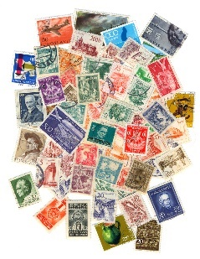
Describe in words, the likelihood of randomly choosing a particular stamp from this pile of stamps.

……………………………………………………………………………

……………………………………………………………………………
In an auto showroom, there are two white cars, two black cars, a red car and a green car.
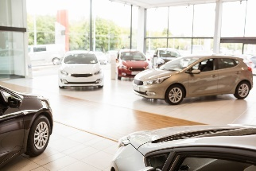
Jane randomly chooses one of these cars to test drive.
What is the probability that it is black?

…………………………………..……………………………

……………………………………..………………………….
At the start of a season, a football commentator says: “The Demons have no chance of winning the flag.”
What probability indicates no chance, and do you think his statement is completely accurate?

……………………………………………………………………………………………....

……………………………………………………………………………………………….
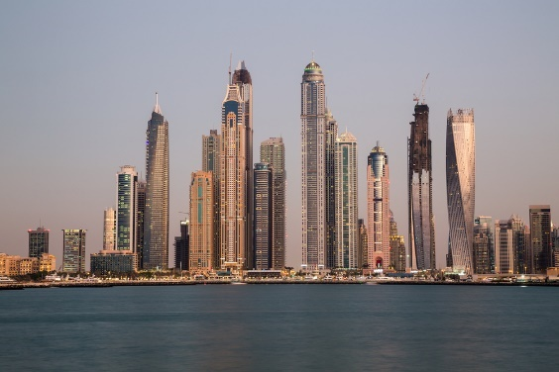
A city has 60 skyscrapers, 25 are hotels, 12 are apartment blocks, 15 are office buildings and the remainder are government buildings.
Margot randomly stops outside a skyscraper.
What is the probability that it is a government building?

………………………………………………

……………………………………………....

………………………………………………
Questions 5 and 6 refer to the following graph.
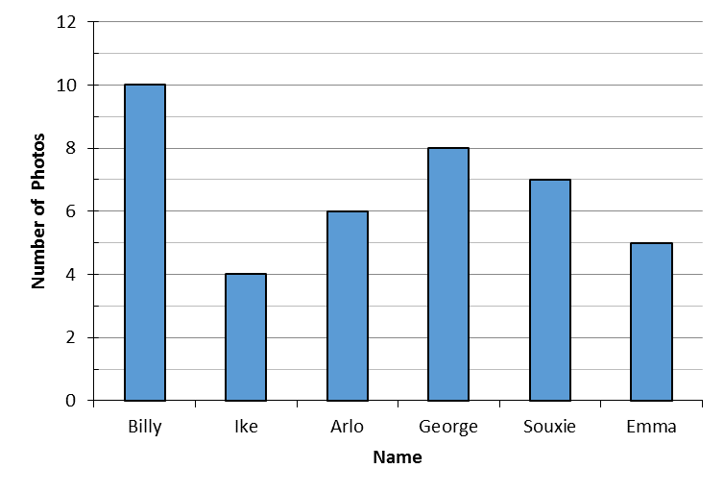
The O’Keefe family printed all their favourite individual photos.
The graph shows how many photos there were of each family member.
One of the photos was chosen at random.
What is the probability that the photo was of Billy?

……………………………………………………………………………………………….
What is the probability that the person in the photo had a name that starts with a vowel?

……………………………………………………………………………………………....

……………………………………………………………………………………………….
Questions 7 and 8 refer to the following.
A pack of cards for a board game are in four colours.
There are 14 red, 16 blue and 30 green and 20 yellow cards.
The cards are shuffled together and one card is drawn at random.

What is the probability that it is not blue?

……………………………………………………………………………………………....

……………………………………………………………………………………………….
What is the probability that it is red or green?

……………………………………………………………………………………………....

……………………………………………………………………………………………….
Questions 9 – 11 refer to the following.
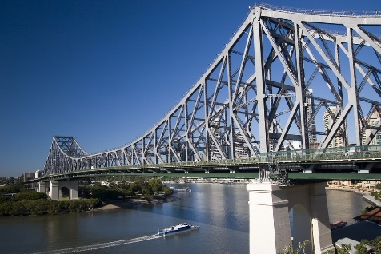
Jimmy records the types of vehicles crossing the Storey Bridge in ten minutes.
The table shows the results.
Vehicle | Number
Sedan | 80
Van | 45
Bus | 20
Truck | 30
SUV | 75

A vehicle crossing the bridge was chosen at random.
What is the probability that the vehicle is a sedan or a SUV?

……………………………………………………………………………………………....

……………………………………………………………………………………………....
What is the probability that it is not a truck or a bus?

……………………………………………………………………………………………....

……………………………………………………………………………………………....
If we know the vehicle is not a truck or bus, what is the probability that it is a sedan?

……………………………………………………………………………………………....

……………………………………………………………………………………………....
Questions 12 – 14 refer to the following:
The table shows the types of holiday that were organised through a travel agent in a month.
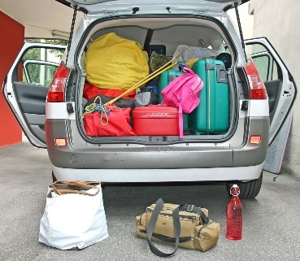
 | Overseas | Australia | Total
Organised Tour | 16 | 24 | 40
Self-Drive Tour | 7 | 13 | 20
Total | 23 | 37 | 60

One holiday is chosen at random from those organised in the month to win a prize.
What is the probability that that the holiday chosen was an organised tour in Australia?

……………………………………………………………………………………………....

……………………………………………………………………………………………....
What is the probability that the holiday chosen was a Self-Drive Tour?

……………………………………………………………………………………………....

……………………………………………………………………………………………....
If we know that the holiday chosen was an Organised Tour, what is the probability that it was in Australia?

……………………………………………………………………………………………....

……………………………………………………………………………………………....
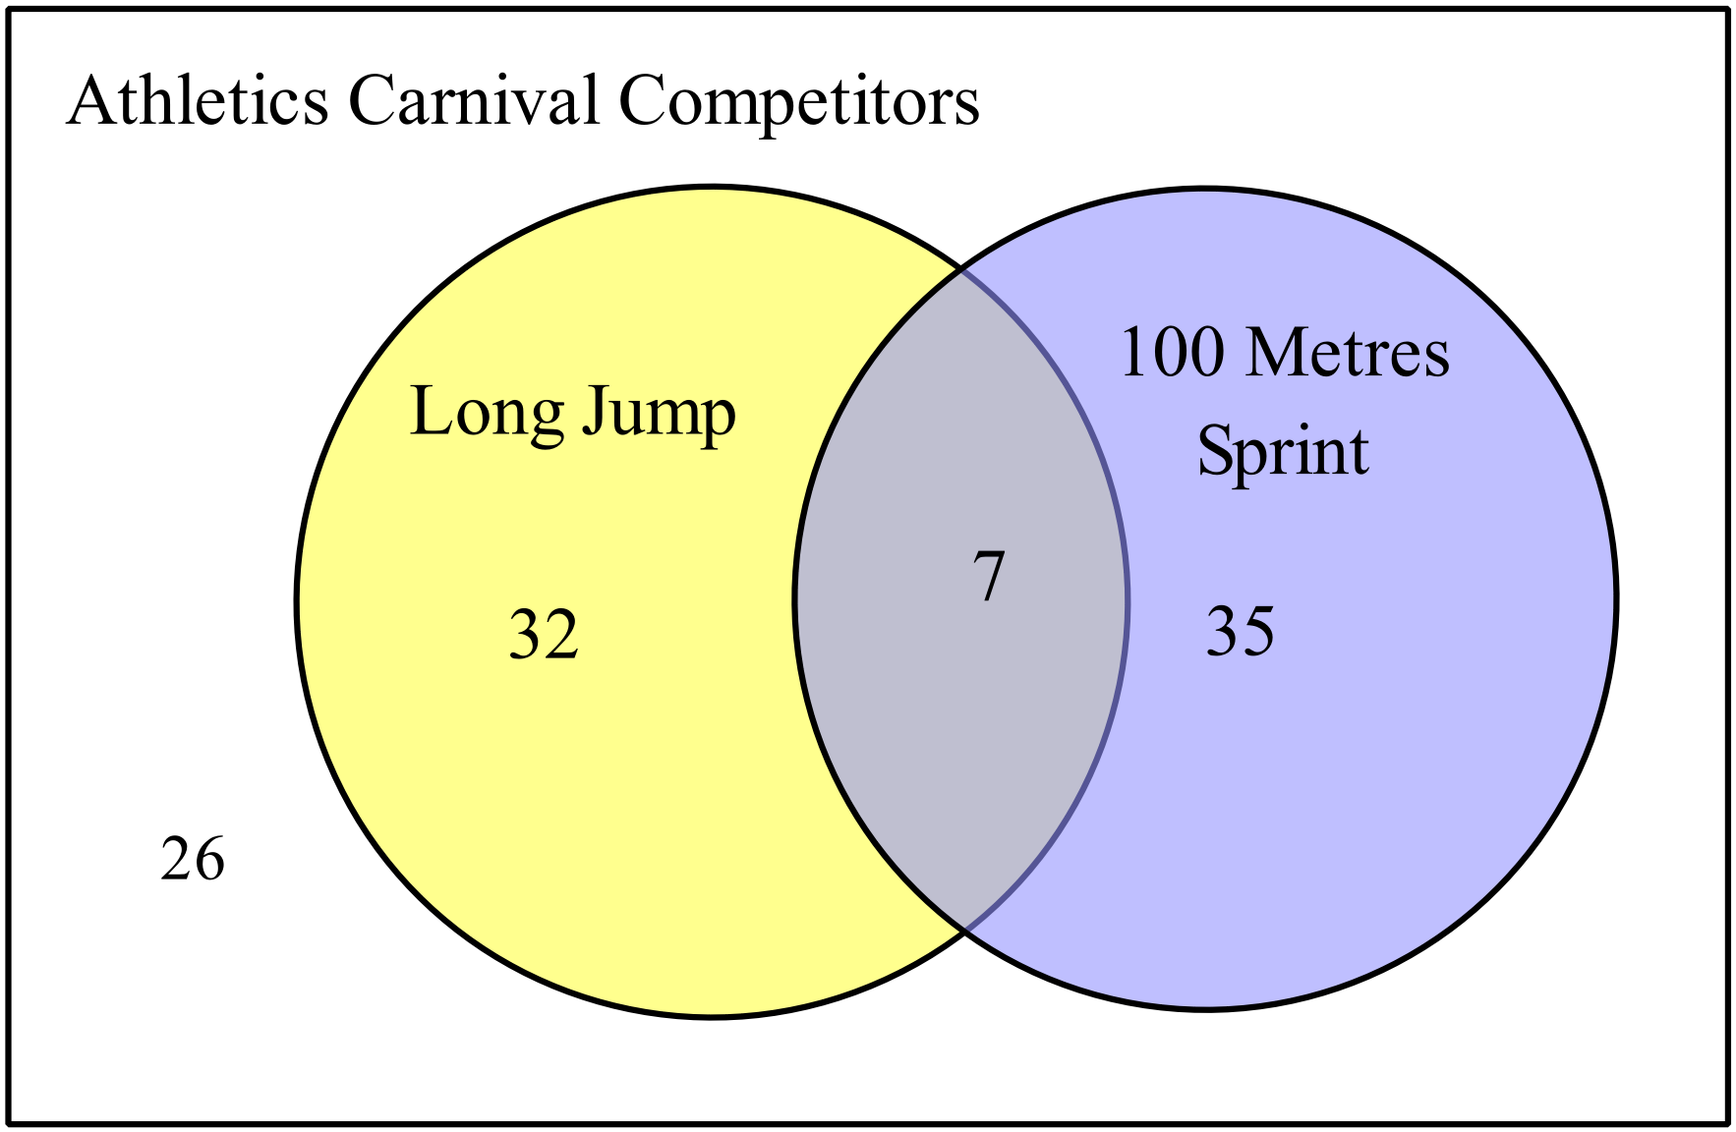Questions 15 – 18 refer to the following:

The Venn diagram illustrates the competitor numbers for two events at the athletics carnival.

A person is chosen at random from those who competed at the carnival.

What is the probability that the person competed in both the long jump and 100 metres sprint?

……………………………………………………………………………………………....

……………………………………………………………………………………………....
What is the probability that the person competed in the long jump but not the 100 metres sprint?

……………………………………………………………………………………………....

……………………………………………………………………………………………...
What is the probability that the person competed in neither the long jump nor the 100 metres sprint?

……………………………………………………………………………………………....

……………………………………………………………………………………………....
What is the probability that the person competed in either the long jump or the 100 metres sprint, but not both?

……………………………………………………………………………………………....

……………………………………………………………………………………………....

School Name
Mathematics 2017
Year 9 |  | Basic Probability | Calculator Allowed
 |  | Basic Probability | Name_________________
Section 2 Multiple Choice Section
Mark all your answers on the accompanying multiple choice answer sheet, not on this test paper. You may do any working out on this test paper. Calculators are allowed for this section.

A normal six-sided die is rolled.
What is the probability that it shows an even number?
A.  B.  C.  D. 
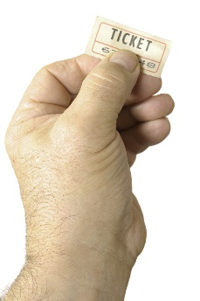
Questions 2 and 3 refer to the following.
A raffle has tickets numbered from 1 – 25.
A single ticket is drawn out to win a prize.

What is the probability that a number less than 6 is drawn?
A.  B.  C.  D. 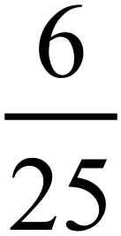
Joe buys all the tickets that have the digit 3 on them.
What is the probability that he wins the prize?
A. 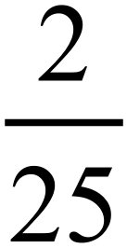 B. 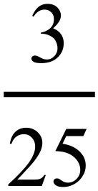 C. 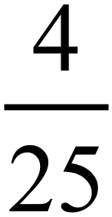 D.
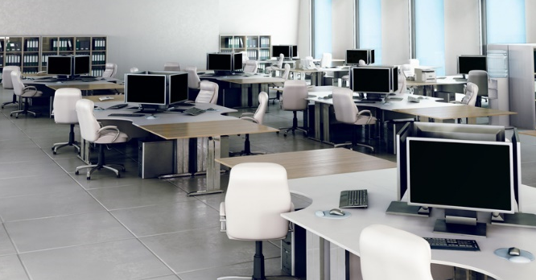
Question 4 – 6 refer to the following.
An office has 40 computer workstations which are numbered from 1 – 40.
The even numbered workstations face the windows and the odd numbered ones face an internal wall.
When each worker arrives at the office, they are randomly allocated to a workstation.
What is the probability that a worker is allocated to a workstation facing the windows?
A.  B.  C. D.
What is the probability that a worker is allocated to a workstation whose number is a multiple of 10?
A. B.  C. D.
What is the probability that a worker is allocated to a workstation whose number is a multiple of 3 and faces the windows?
A.  B. C.  D.
Rhoda has 1 coat, 3 pullovers, 2 jackets and 4 cardigans to wear if the weather is cold.
On a chilly morning, she chooses one of these at random.
What is the probability that she wears a jacket?
A. 0.1 B. 0.2 C. 0.3 D. 0.4
Questions 8 and 9 refer to the following:
The table shows the breakfast menu at The Blues Café, and the number of each that were ordered on a certain morning.
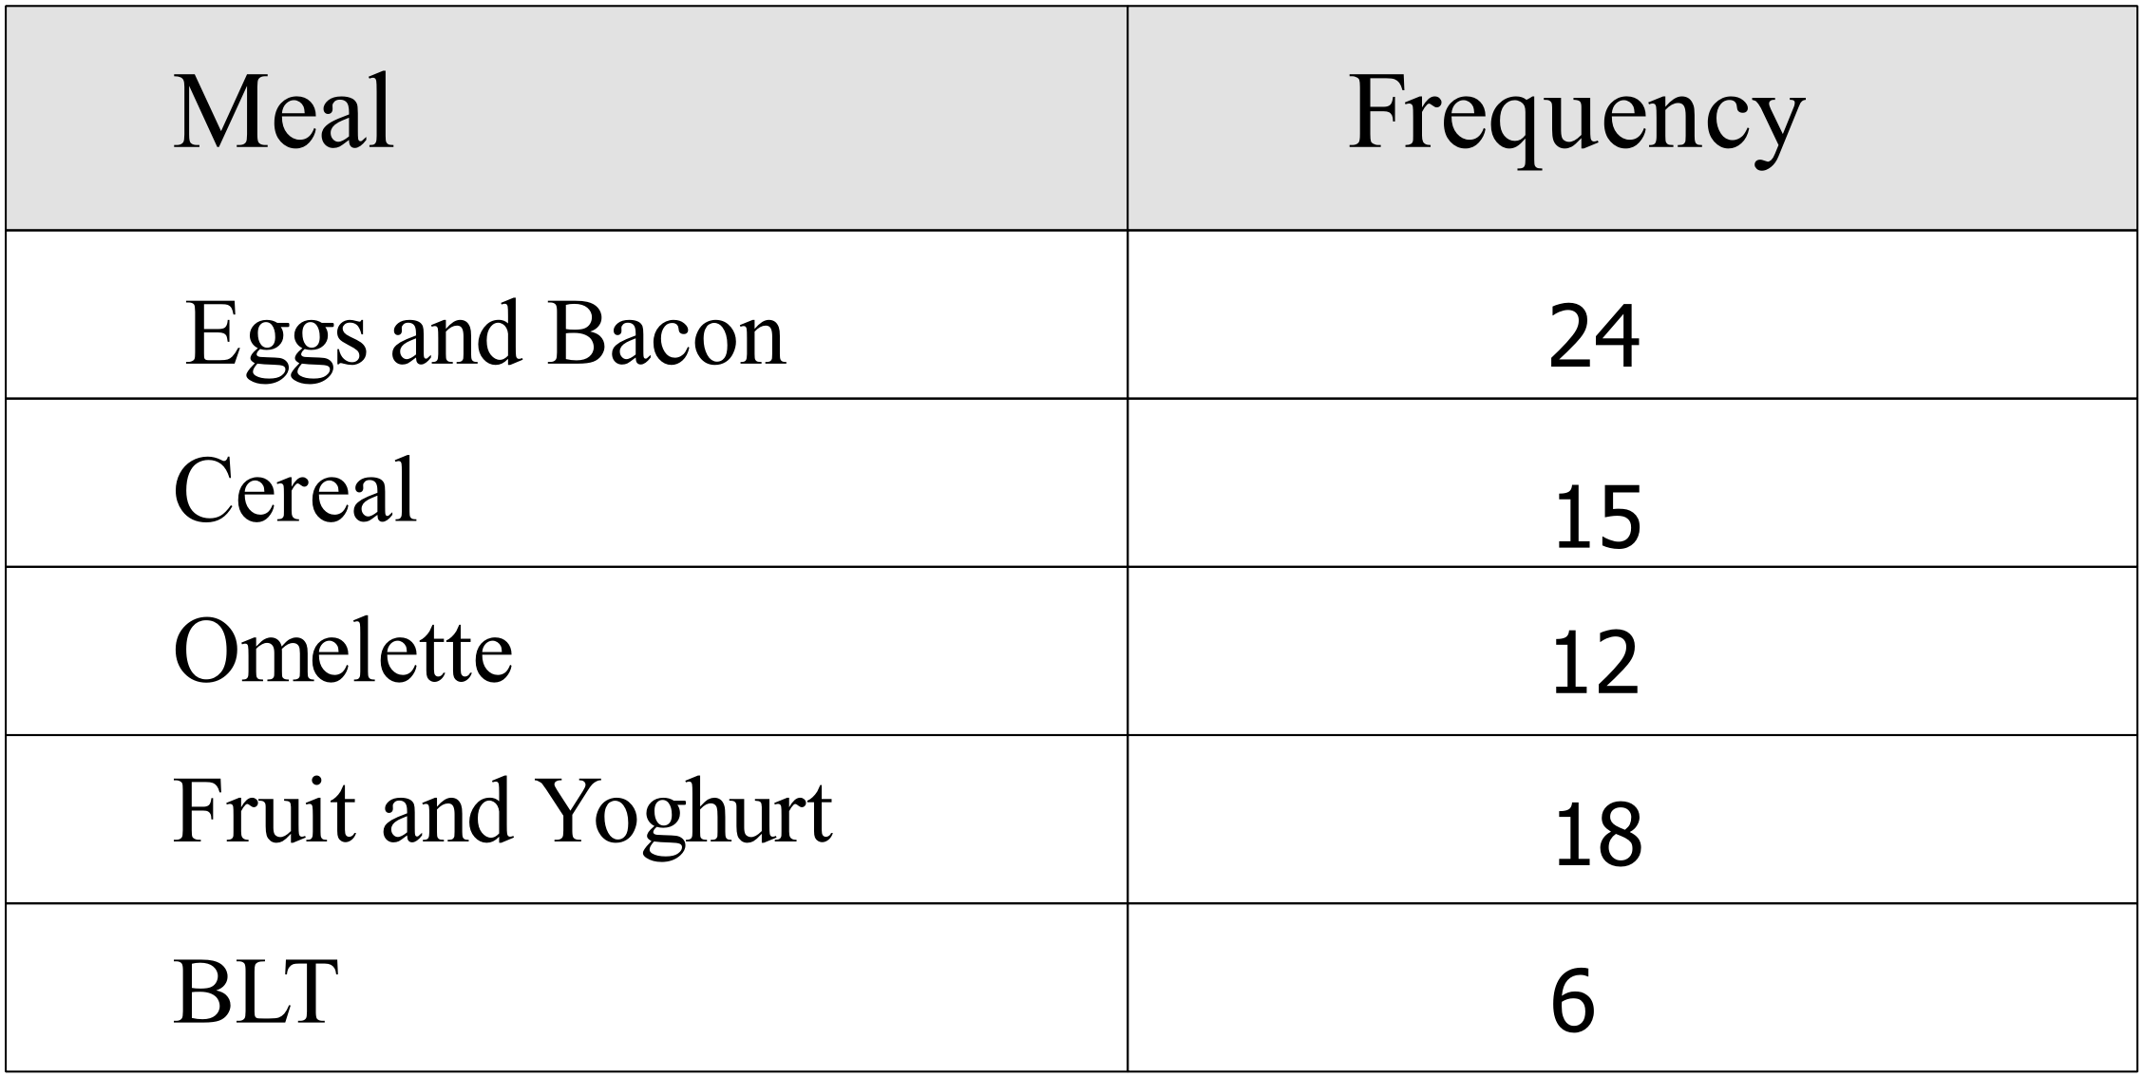
One of their breakfast customers is chosen at random to provide a review.

What is the probability that the customer had either eggs and bacon or an omelette?

A. B. 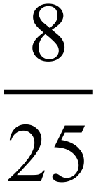 C. 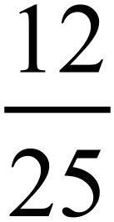 D. 
What is the probability that the customer didn’t have Cereal?
A.  B. C.  D. 
Questions 10 – 12 refer to the following:
Two hotels were reviewed by travellers on a travel website.

The table shows the ratings which went with the reviews.
Review Rating | The Regent | The Meridian
5 star | 14 | 16
4 star | 22 | 18
3 star | 9 | 21
2 star or less | 5 | 5
Total | 50 | 60

Based on these results, which hotel is more likely to get a 5-star rating?
A. The Meridian is more likely.
B. The Regent is more likely.
C. They are equally likely.
D. There isn’t enough information to decide.
One of the reviews in the table is selected at random.
What is the probability that the review gave 3 stars to the hotel used?

A. 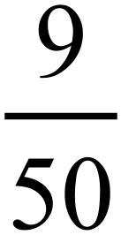 B.  C.  D. 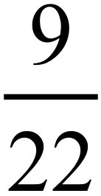
One of the reviews that gave 4 stars is selected at random.
What is the probability that it was for The Meridian?

A. B. C. 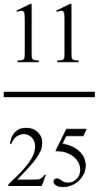 D. 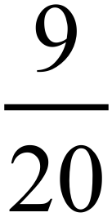
Questions 13 -15 refer to the following:
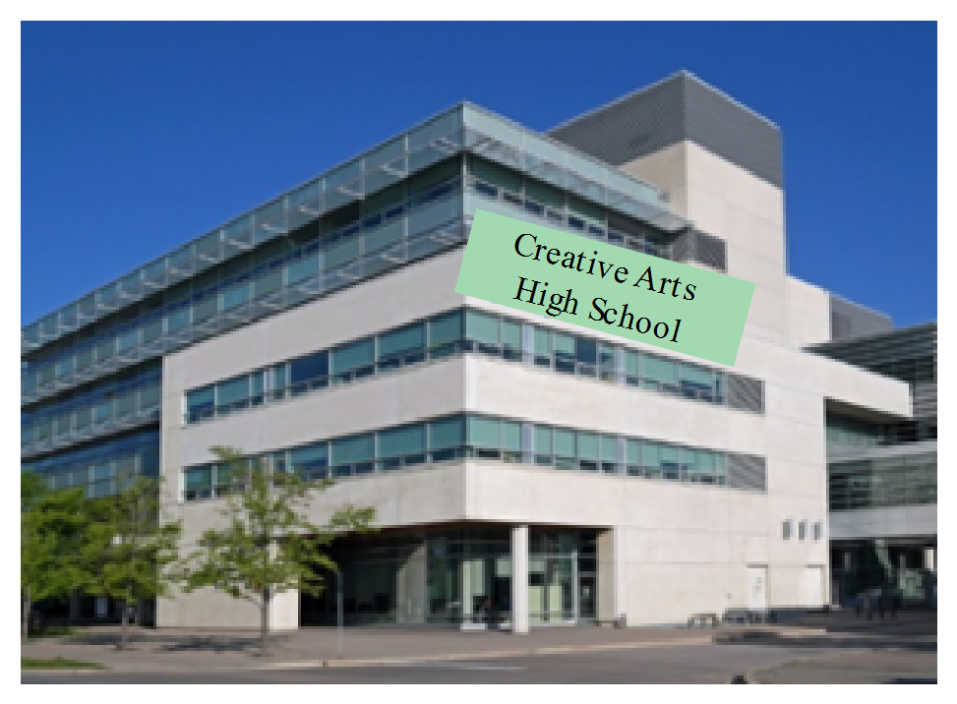The table below records the number of visual arts students and performing arts students at a creative arts high school.

 | Male | Female | Total
Visual Artist | 120 | 155 | 275
Performer | 150 | 175 | 325
Total | 270 | 330 | 600

Erin chose one student at random to do a radio interview.
What is the probability that the student is a male visual artist?
A. B. 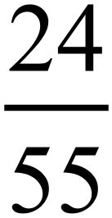 C.  D. 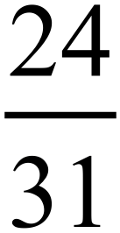
What is the probability that the student is female?
A.  B. C.  D. 
If we know that the person she chose was male, what is the probability that he was a performer?
A.  B. C. 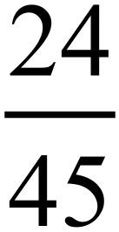 D. 
Questions 16 – 18 refer to the following:
The Venn diagram shows the results of a survey on how people watched the TV Series Mad About Cats.
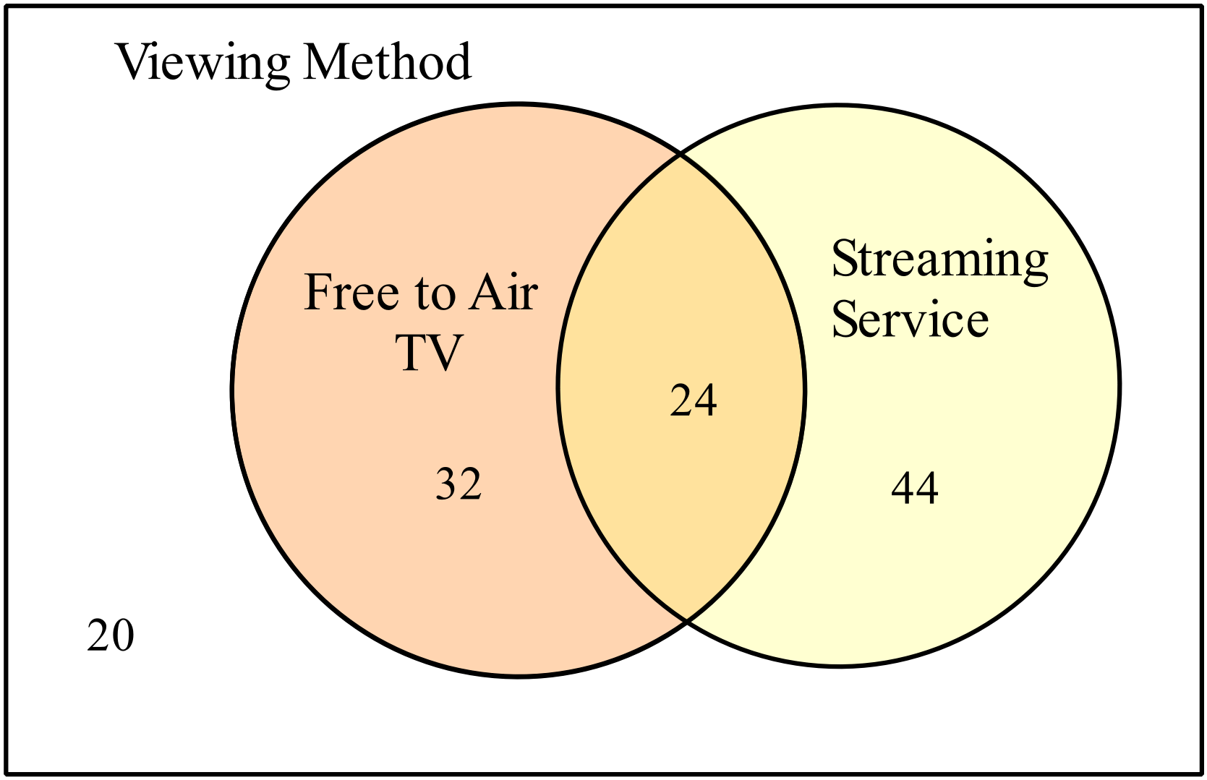



One of the survey responses is chosen at random.
What is the probability that the person only used a Streaming Service to watch the program?

A.  B. C.  D. 
What is the probability that the person used a method other than Free to Air TV or a Streaming Service to watch the program?

A. B. 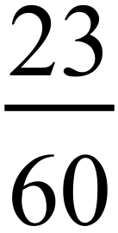 C. 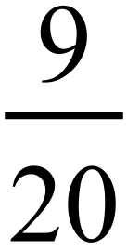 D. 
If we know that the person watched on Free to Air TV, what is the probability that the person also used a Streaming Service?

A.  B.  C. D.

School Name
Mathematics 2017
Multiple Choice Answer Sheet
Basic Probability
Name _____________________________________________
Completely fill the response oval representing the most correct answer.
1. A B C D
2. A B C D
3. A B C D
4. A B C D
5. A B C D
6. A B C D
7. A B C D
8. A B C D
9. A B C D
10. A B C D
11. A B C D
12. A B C D
13. A B C D
14. A B C D
15. A B C D
16. A B C D
17. A B C D
18. A B C D

School Name
Mathematics Test 2017
Year 9 | Basic Probability | Non Calculator Section
ANSWERS

Question | Working and Answer
 | Choosing one from many could be described as very unlikely or words to that effect.
 | 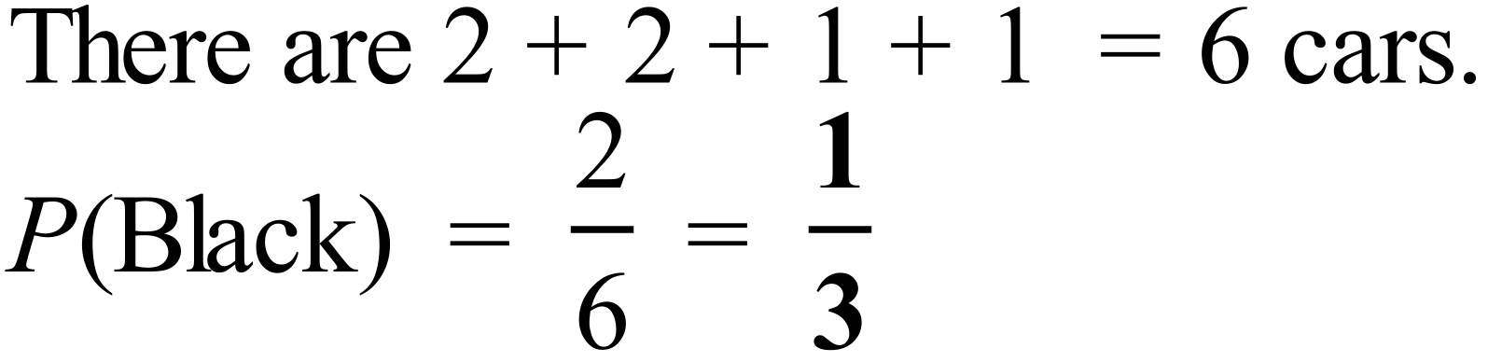
No chance indicates impossible which has a probability of 0.
The term is used colloquially by the commentator, it may be almost impossible for the Demons to win, but it cannot be impossible as all many unlikely things could occur which makes it possible for them to win.
 | 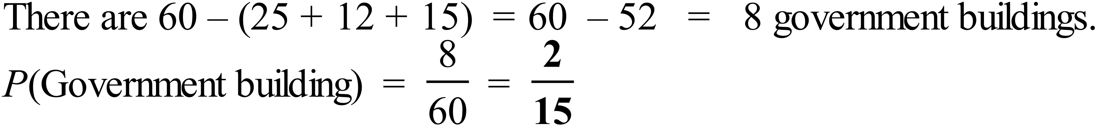
There are 10 years altogether and 6 before 2011.
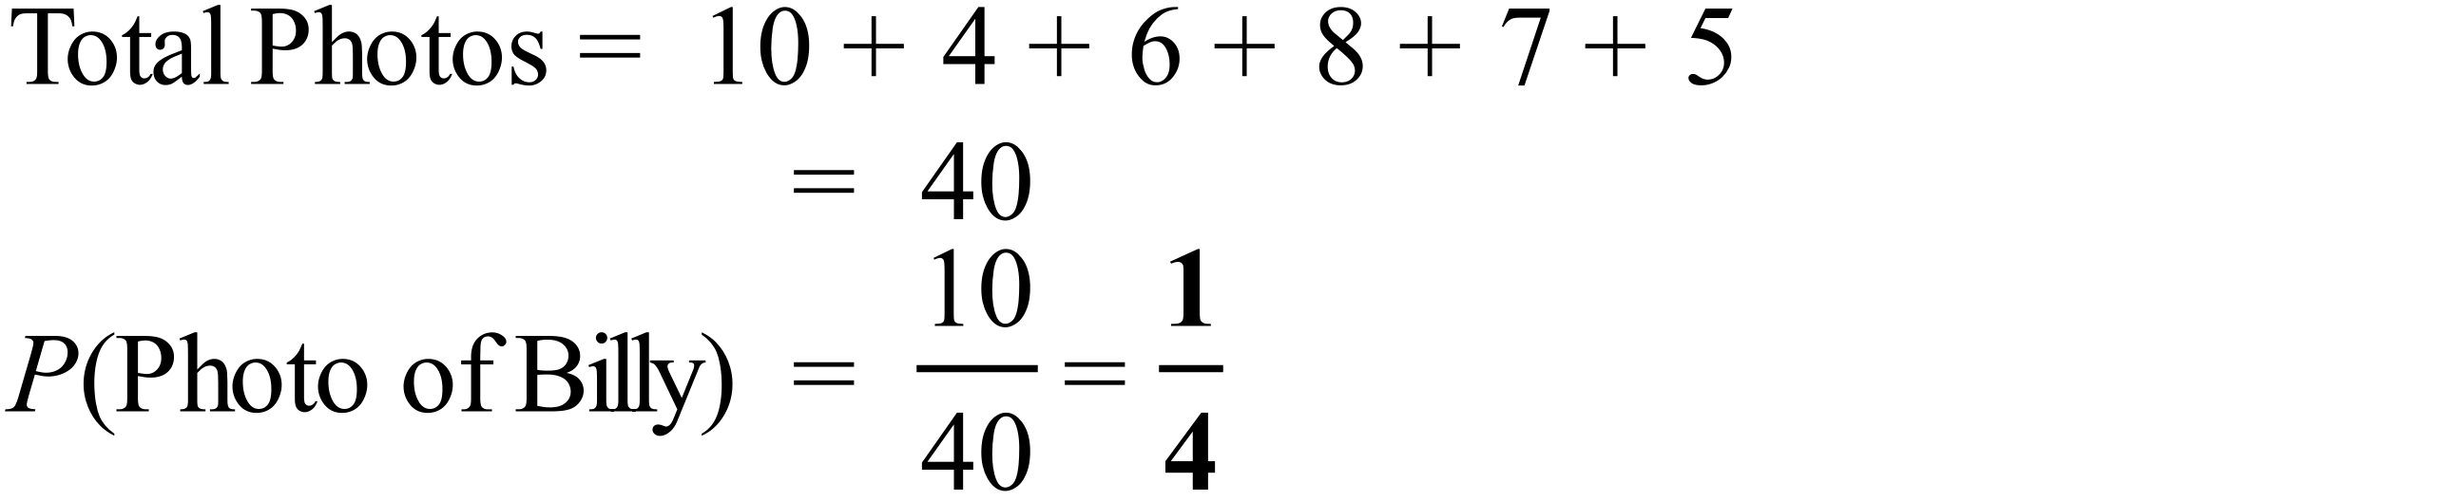
Ike, Arlo and Emma start with a vowel.
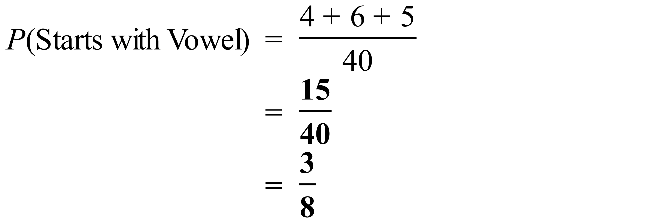
 | 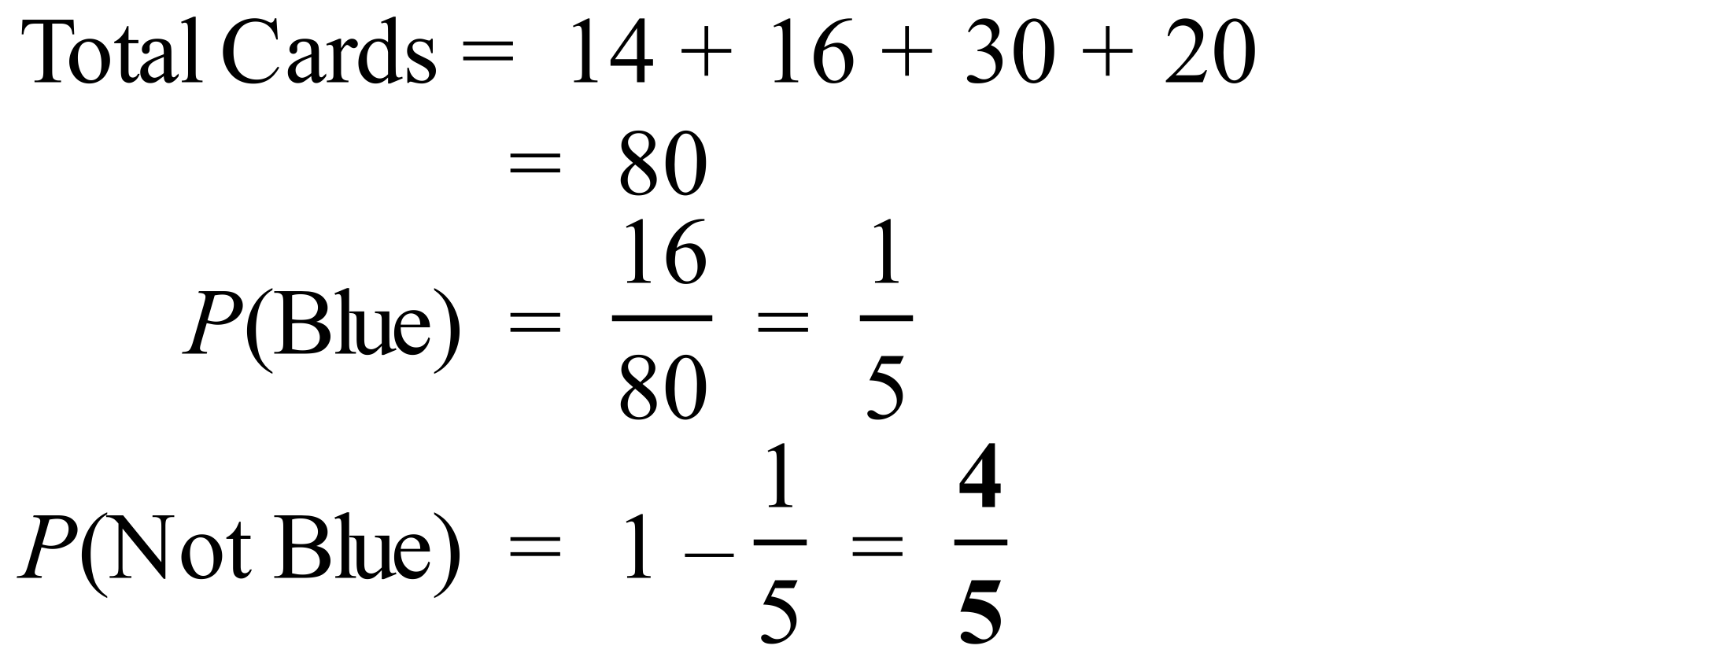
 | 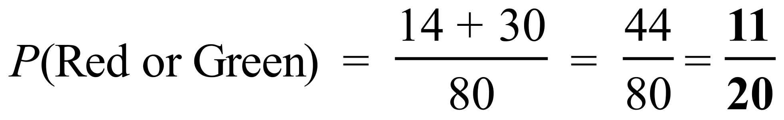
 | 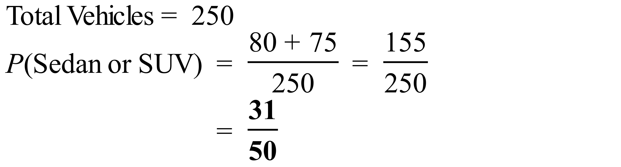
 | 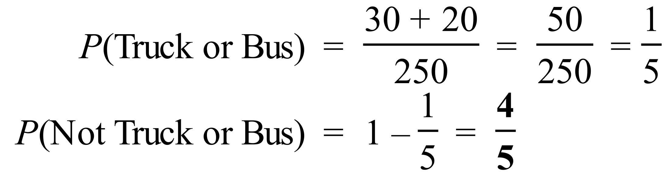
 | 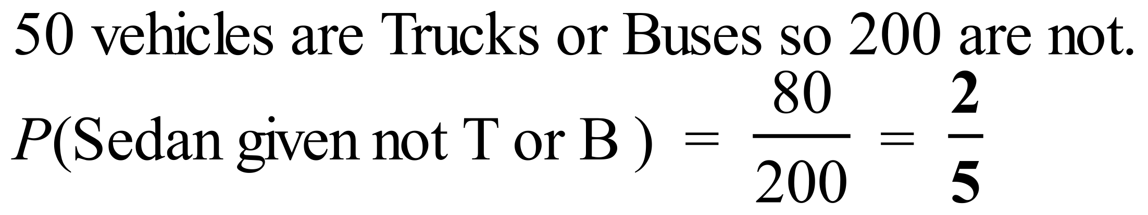
 | 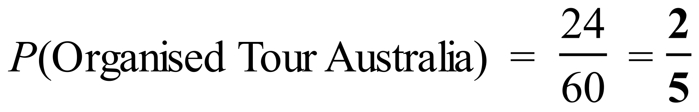
 | 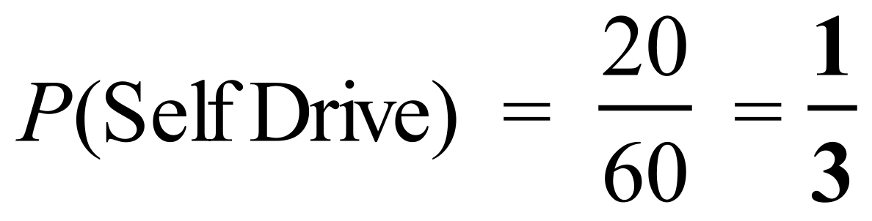
 | 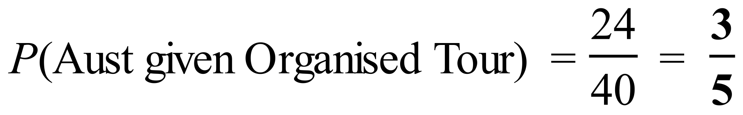
 | 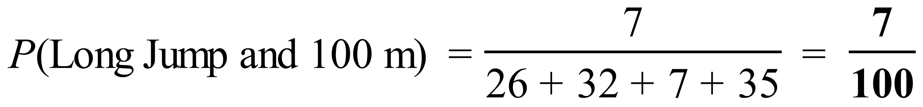
 | 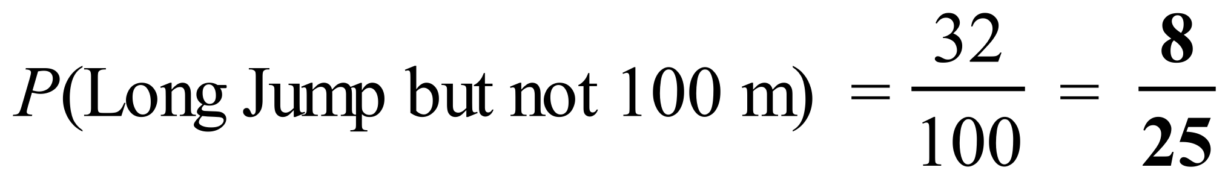
 | 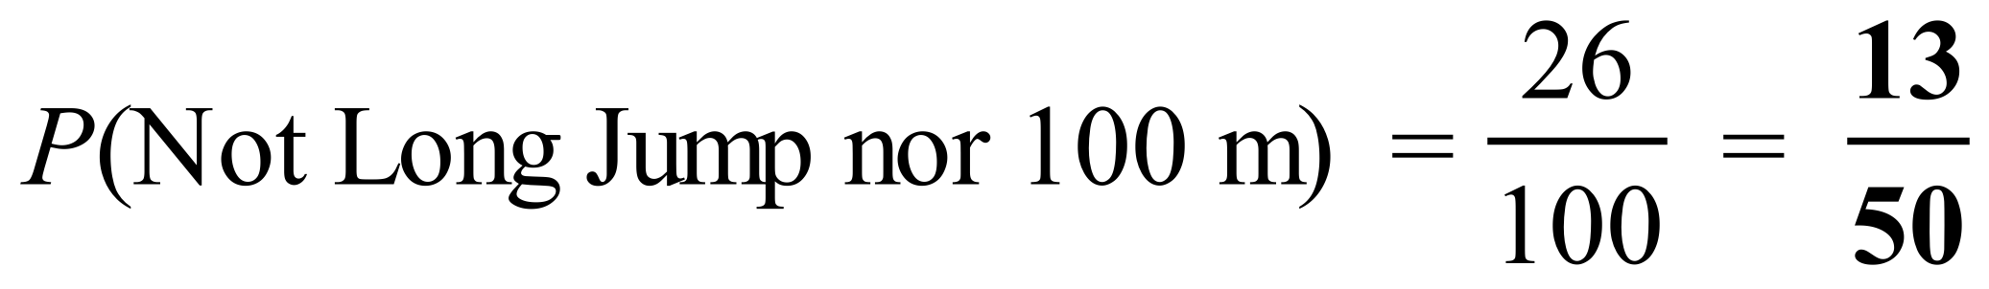
 | 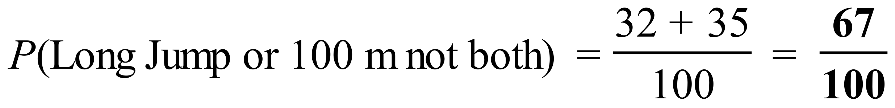

School Name
Mathematics Test 2017
Year 9 | Basic Probability | Calculator Allowed  Multiple Choice  Section

ANSWERS

Question | Working | Answer
 | There are 3 even numbers out of 6.  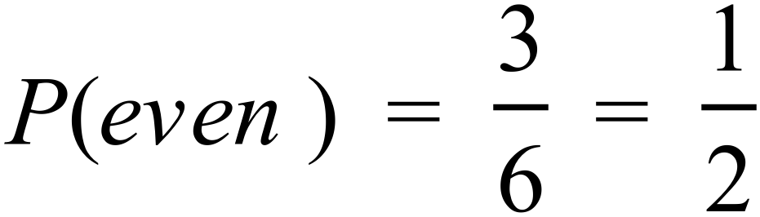 | D
 | 1 – 5 are less than 6.  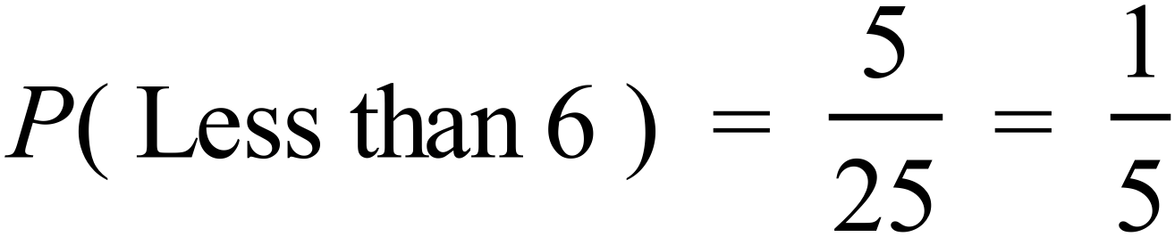 | C
 | Numbers with a digit 3 are 3, 13 and 23.  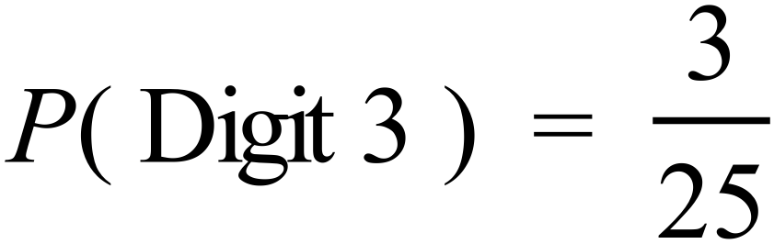 | B
 | 20 of the stations will be even numbered  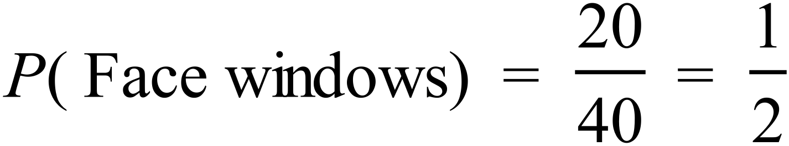 | D
 | Stations which are a multiple of 10 are, 10, 20, 30 and 40.  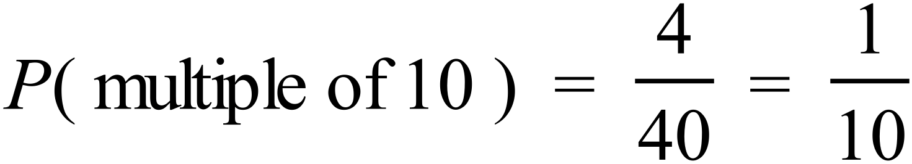 | A
 | Stations which are a multiple of 3 are, 3, 6, 9,12, 15, 18, 21, 24, 27, 30, 33, 36, and 39  Those which face windows are even, so choose the even numbers above. 6, 12, 18, 24, 30, 33  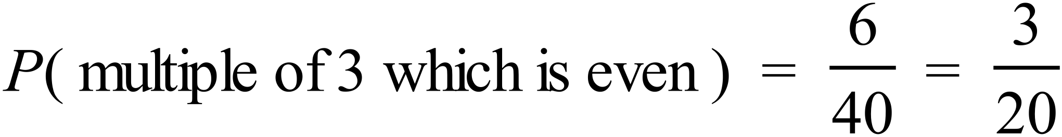 | A
 | 2 jackets out of 10 garments  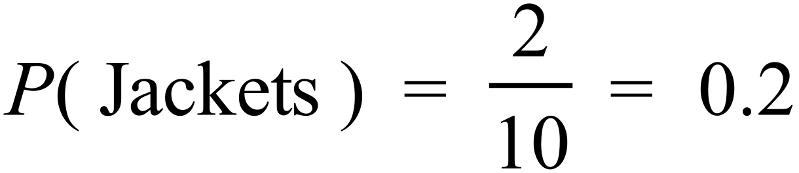 | B
 | There are 24 + 15 + 12 + 18 + 6 = 75 meals  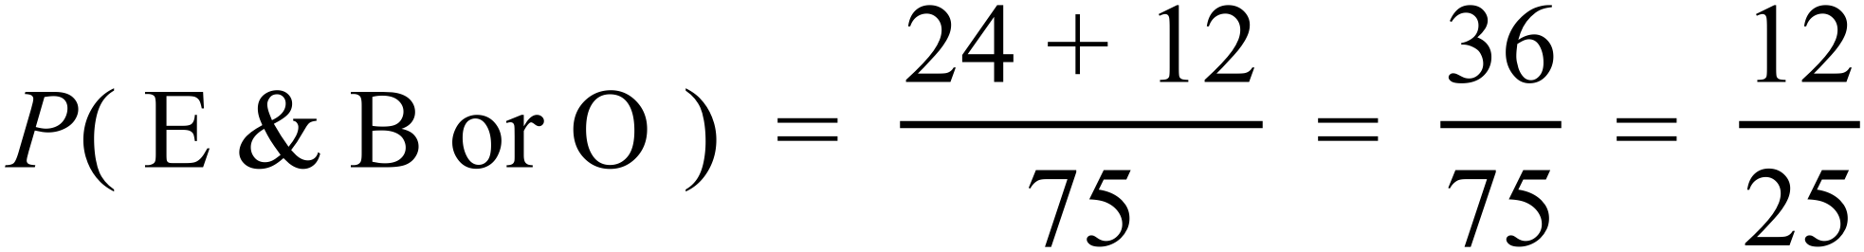 | C
 | 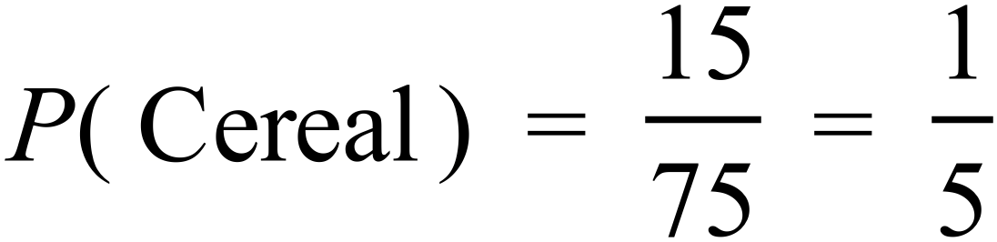  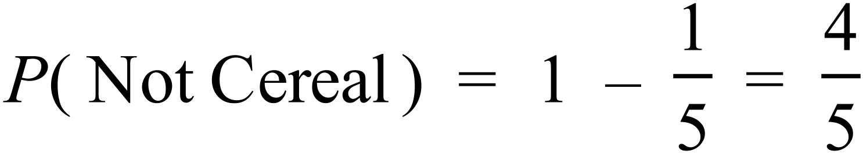 | D
 | 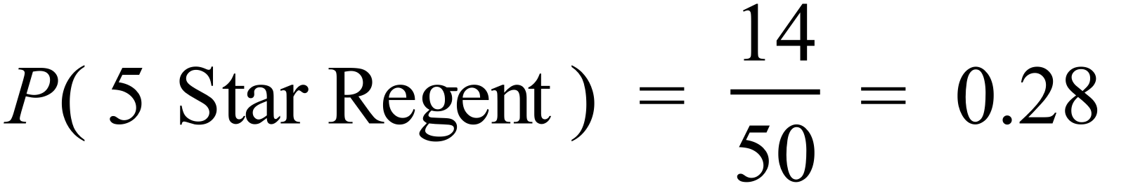  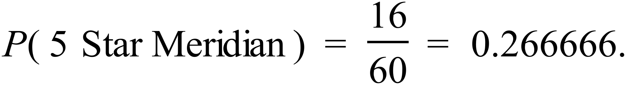  Based on this, The Regent is more likely to get 5 stars. | B
 | Number of 3 star reviews = 9+21 = 30  Total = 50 + 60 = 110  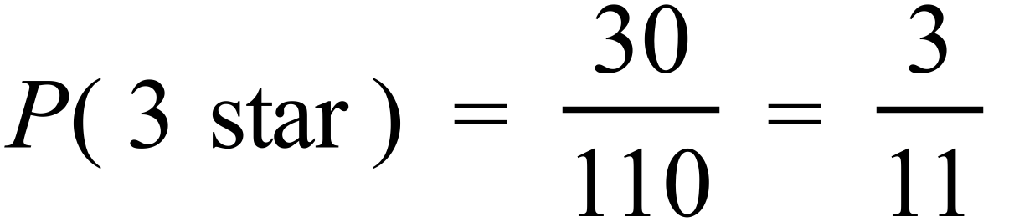 | B
 | 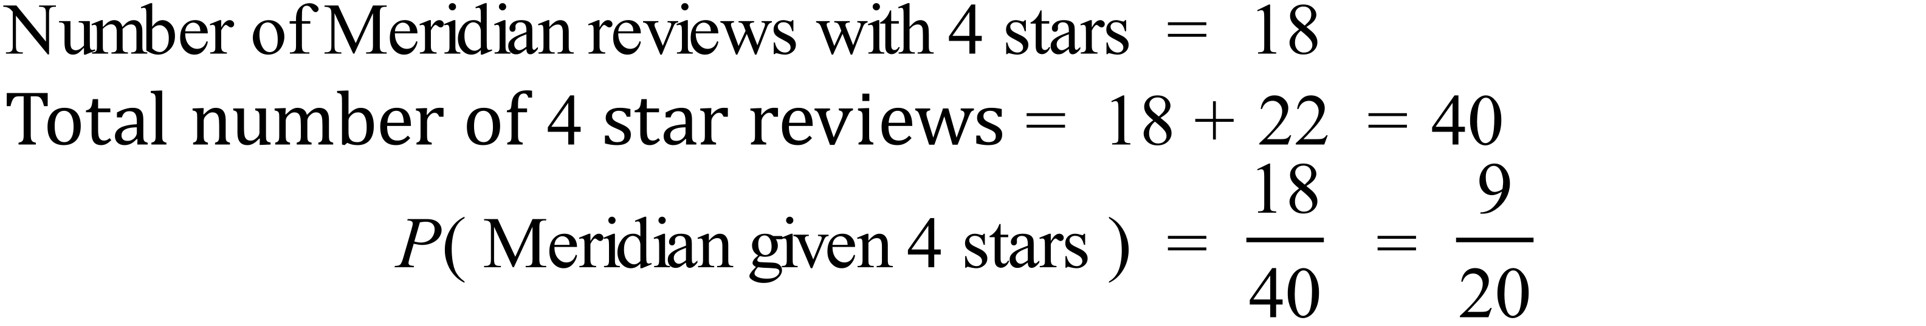 | D
 | 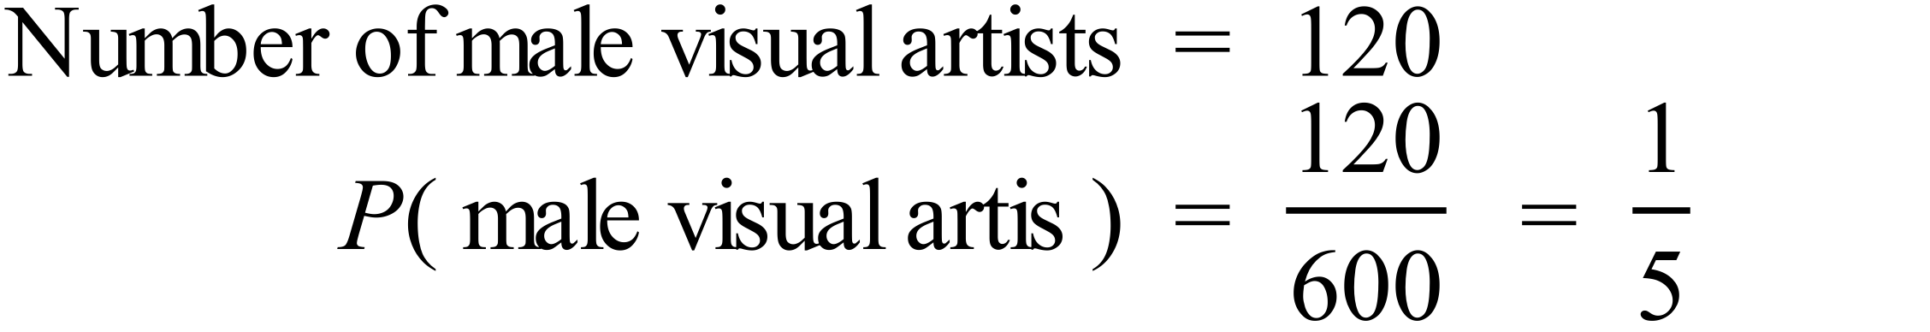 | A
 | 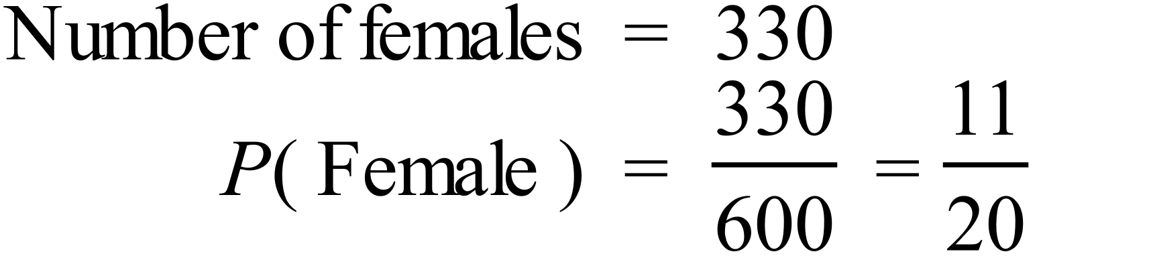 | C
 | 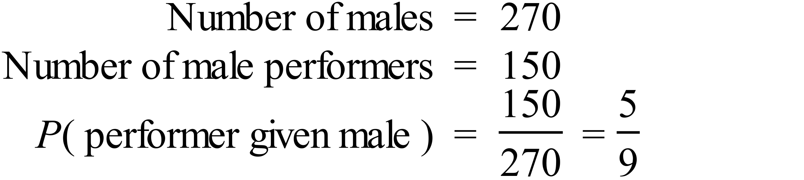 | D
 | 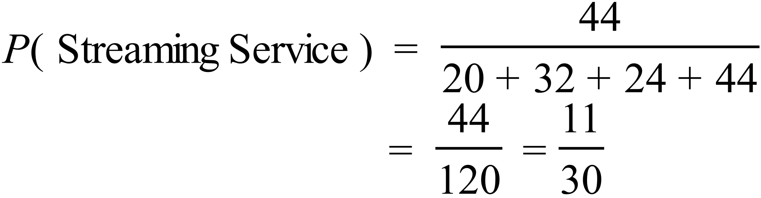 | D
 | 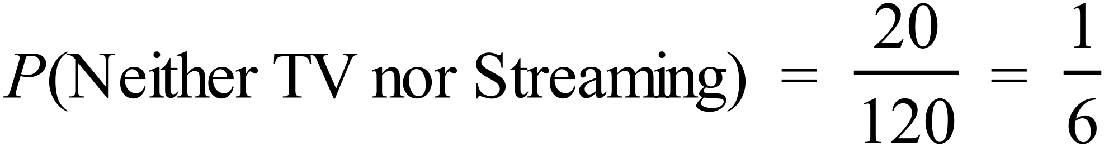 | A
 | 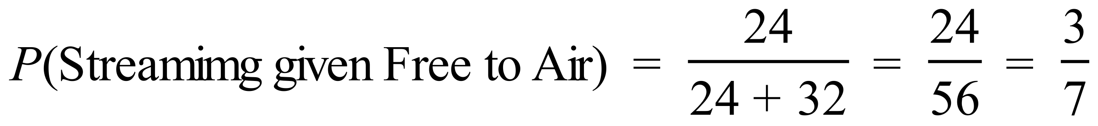 | B

School Name
Mathematics 2017
Multiple Choice Answer Sheet
Basic Probability
Name _____________________________________________
Completely fill the response oval representing the most correct answer.
1. A B C D
2. A B C D
3. A B C D
4. A B C D
5. A B C D
6. A B C D
7. A B C D
8. A B C D
9. A B C D
10. A B C D
11. A B C D
12. A B C D
13. A B C D
14. A B C D
15. A B C D
16. A B C D
17. A B C D
18. A B C D

